Rehab Building At Sion.

1. Project Information
- Project Name: Prince Residency I & II
- Location: __________________
- Plot Area: __________________
- Built-up Area: __________________
- Project Type: Residential redevelopment
- Client/Developer: Transindia Group
- Status: __________________
- Completion Year: __________________

2. Project Overview
Prince Residency is a residential redevelopment comprising high-rise and mid-rise residential wings. The project focuses on efficient planning, a contemporary façade and a unified architectural identity. Its clean elevation and strong vertical composition create a prominent presence within the urban surroundings.

3. Building Features
- High-rise and mid-rise residential wings
- Repetitive framed window modules
- Strong vertical façade bands
- White, grey and brown colour palette
- Decorative textured panels
- Project branding integrated into the crown
- Large windows for natural light and ventilation
- Stilt and podium-level circulation
- Defined entrance and common areas
- Simple, durable and low-maintenance façade treatment

4. Overall Design Concept
The design uses strong vertical frames, contrasting colour bands and repetitive window patterns to visually reduce the building’s scale. White surfaces create brightness, while grey and brown accents add depth and definition. The overall concept is functional, contemporary and suitable for a high-density residential redevelopment.

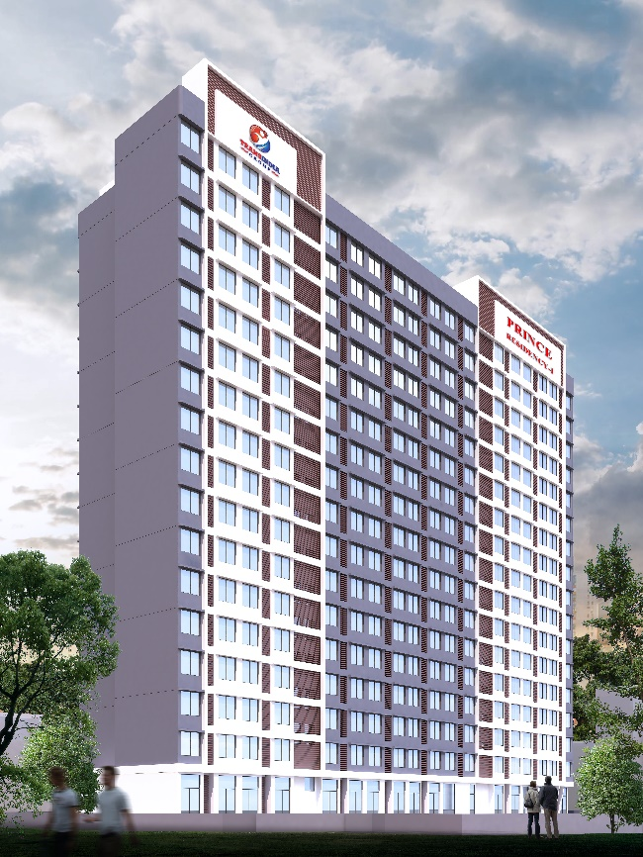
Image 4.
Image 3.
Image 1.
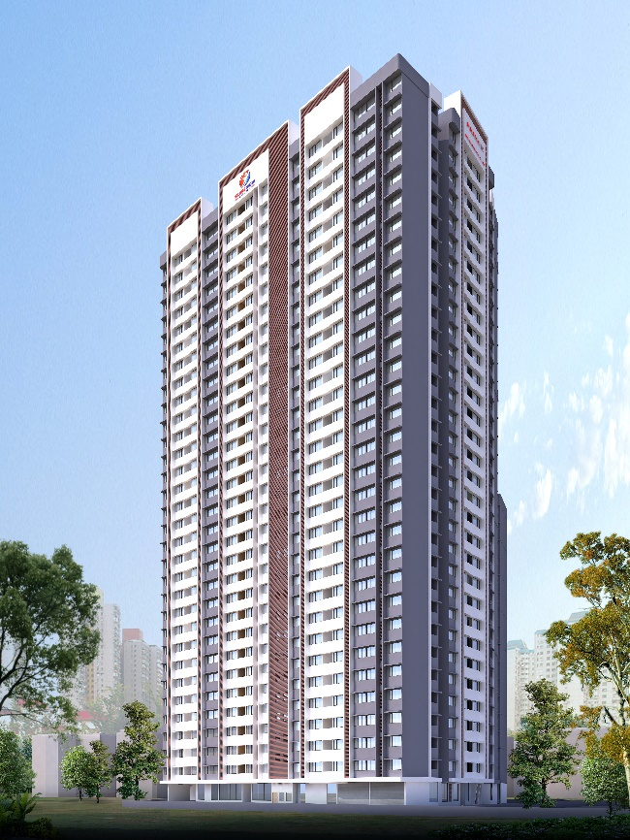
Image 2.
